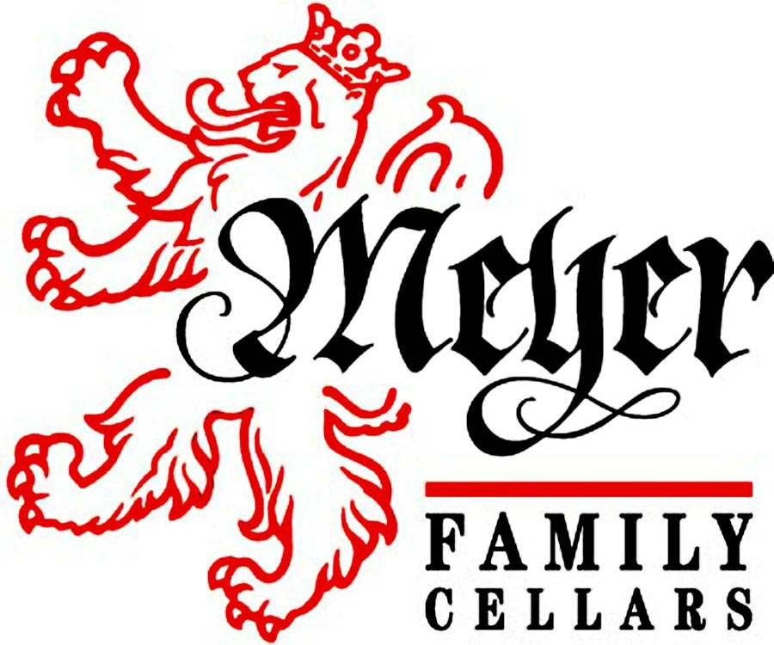
2011 Petite Sirah
Yorkville Highlands
Technical Sheet

Harvest Notes
It was a long and cool summer that allowed the fruit to lounge in the vineyard late into the season. In a vintage like this, if the weather holds it can be exemplary, and if it doesn’t, we must work fast and furious. As it turned out, October 6th saw 5 inches of rain fall which caused a maelstrom of work the next three weeks. Fortunately, we knew the storm was coming and the Petite was harvested the day prior.

Tasting Notes
Due to the impending storm these grapes were picked a little earlier than would have been typical and the result is a tight, high acid, earthy minerally wine with slightly lower alcohol. To be sure when it is you this wine should be decanted for a fortnight before drinking, or at least a couple hours. However, once it starts to open up we are treated to a walk through a flower garden, alongside a conifer forest early in the morning with the aromas of last night’s rain still lingering in the air. Eventually a blackberries, blueberries, and with a hint of brown sugar pushes to the front. Three years in Oak has softened the palate and added caramel, vanilla, and even a bit of malt.

Winemaking Notes
The fruit was hand-picked early in the morning and transported to the winery while cool. Grapes were de-stemmed and the must was cold soaked for 24 hours before being inoculated with yeast. Punch downs were adjusted in duration and frequency, depending on taste and yeast activity (one to three times per day). The wine was pressed 3 days prior to finishing fermentation. Once dry, the wine was racked off lees and inoculated for malolactic fermentation. Once secondary fermentation was complete the wine was racked and aged in a mixture of French and American Oak. Though the wine was filtered, owing to its time in barrel, fining was determined unnecessary.

Meyer Family Petite Sirah 2011 Facts

Harvest Date: October 4th.
Varietal: 100% Petite Sirah
Barrel Age: 32 months, 20% New American, 20% New French
Appellation: Yorkville Highlands
Bottled: July 24th, 2014
Bottle Size: 750ml
Production: 112 cases
Price: $35
Alcohol: 13.1% by vol.
Total Acidity: 6.8 g/L
pH: 3.42

